Login page

What you want to play

Selecting topics

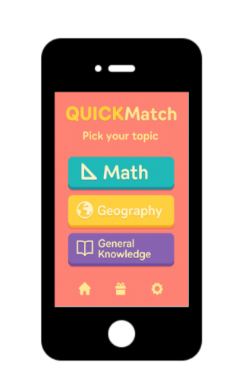

What level of maths you want

1v1 other players

During the quiz

Results

